gantt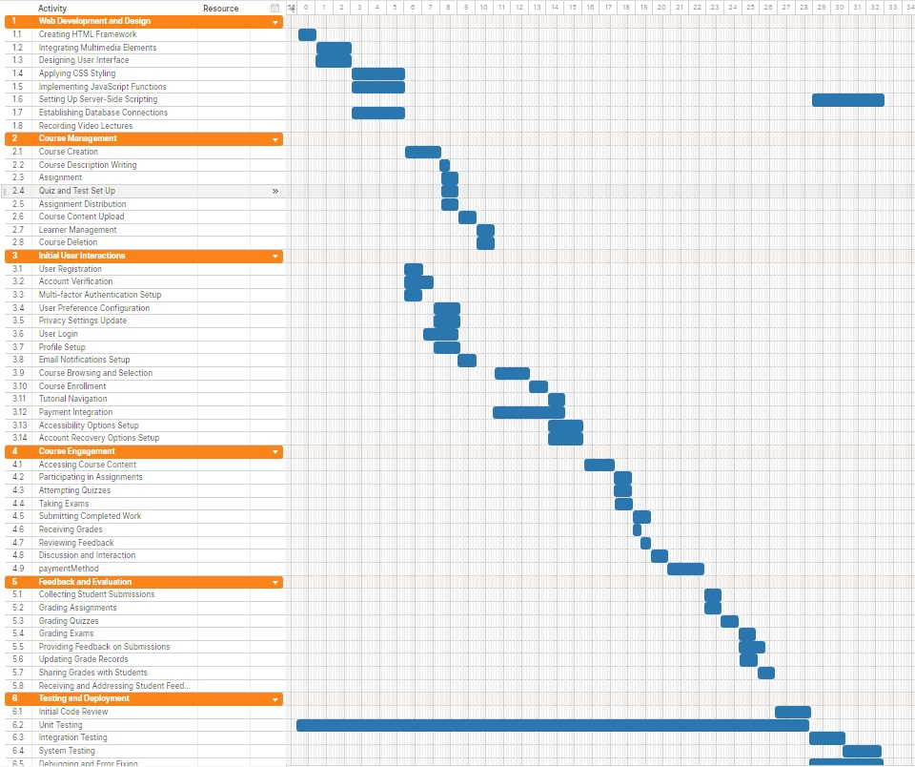

pert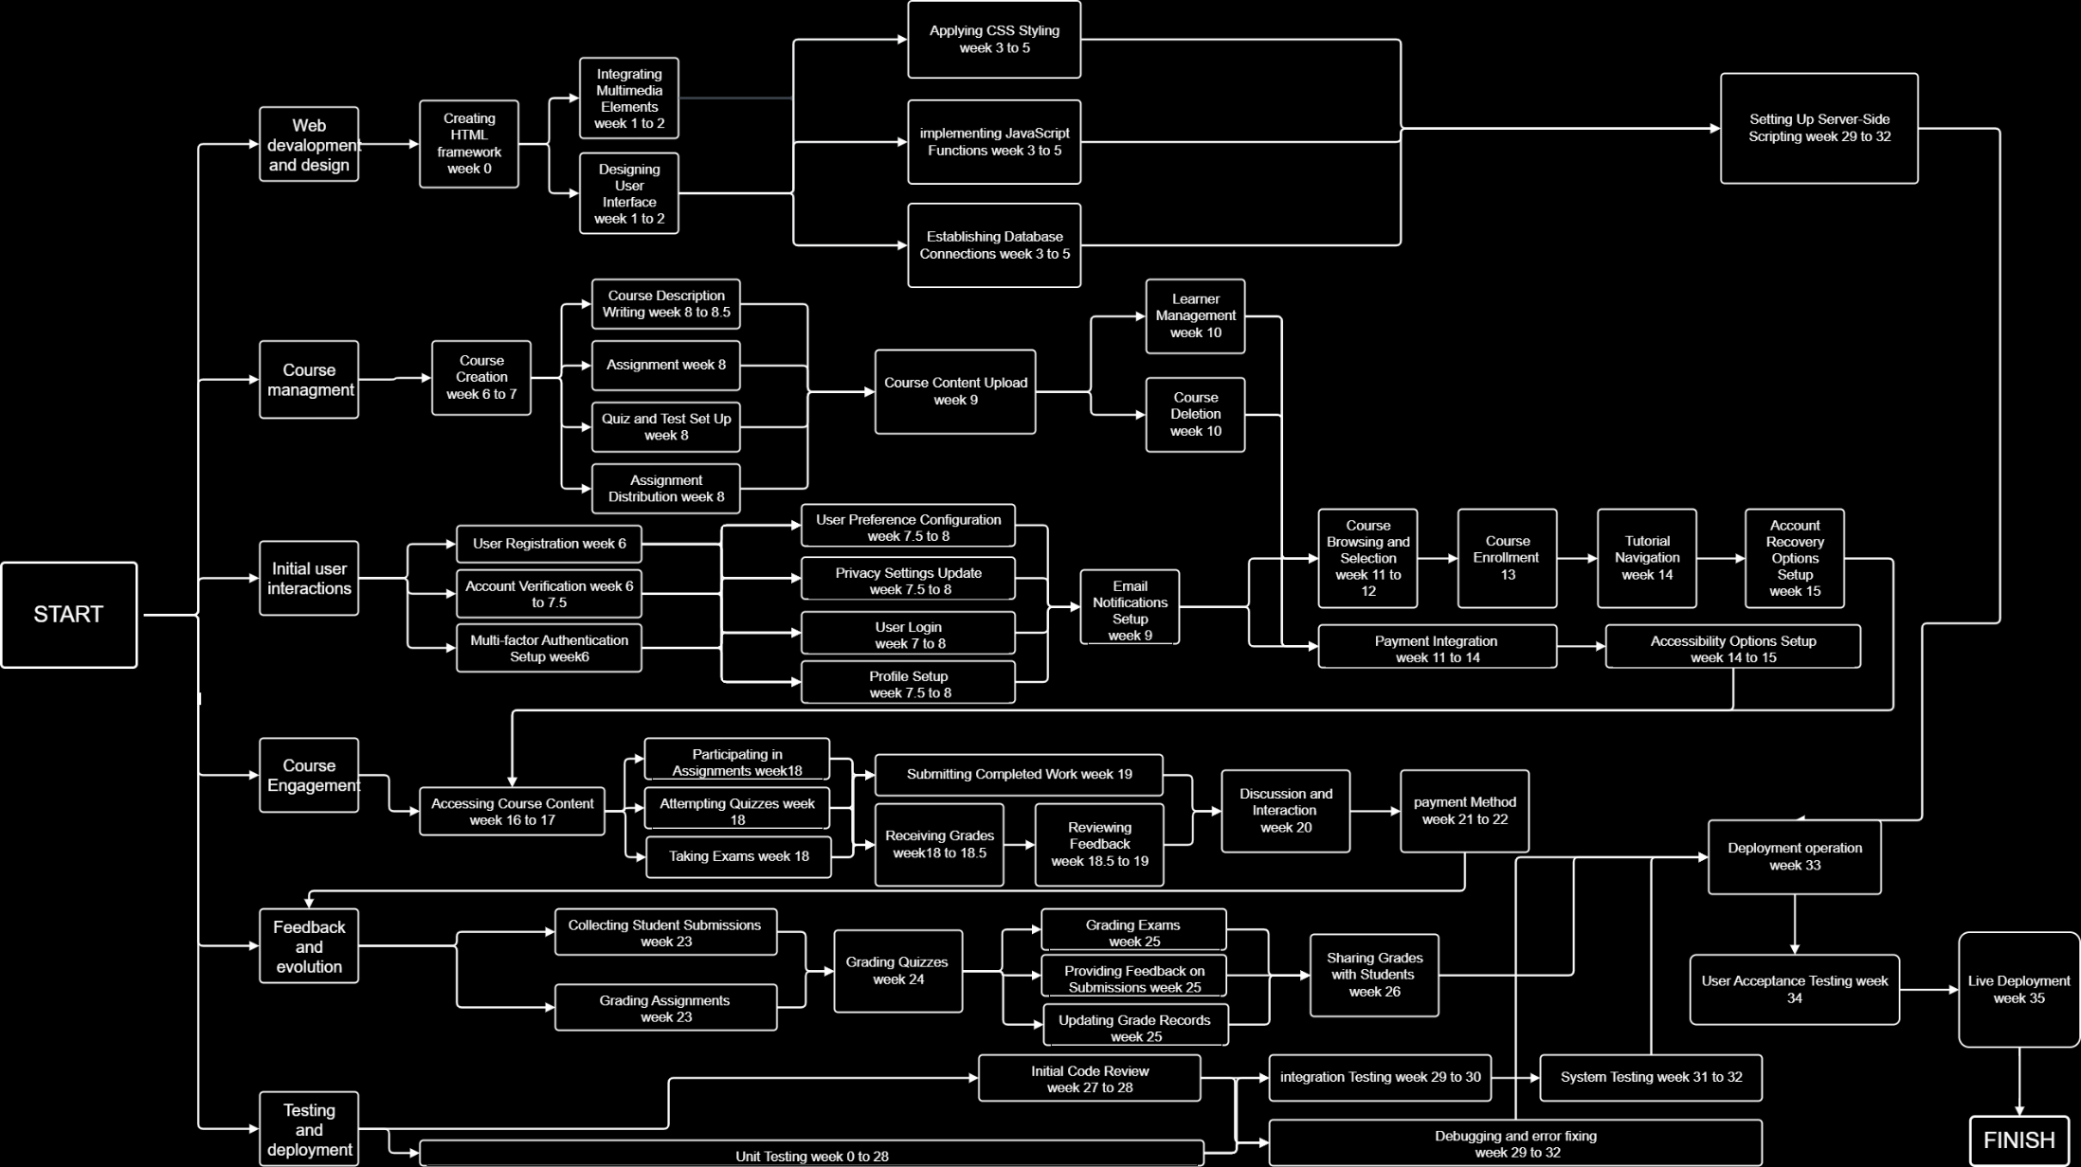

ahmad ghraieb – anwar zaidani – ali aoun